Muscles of hand
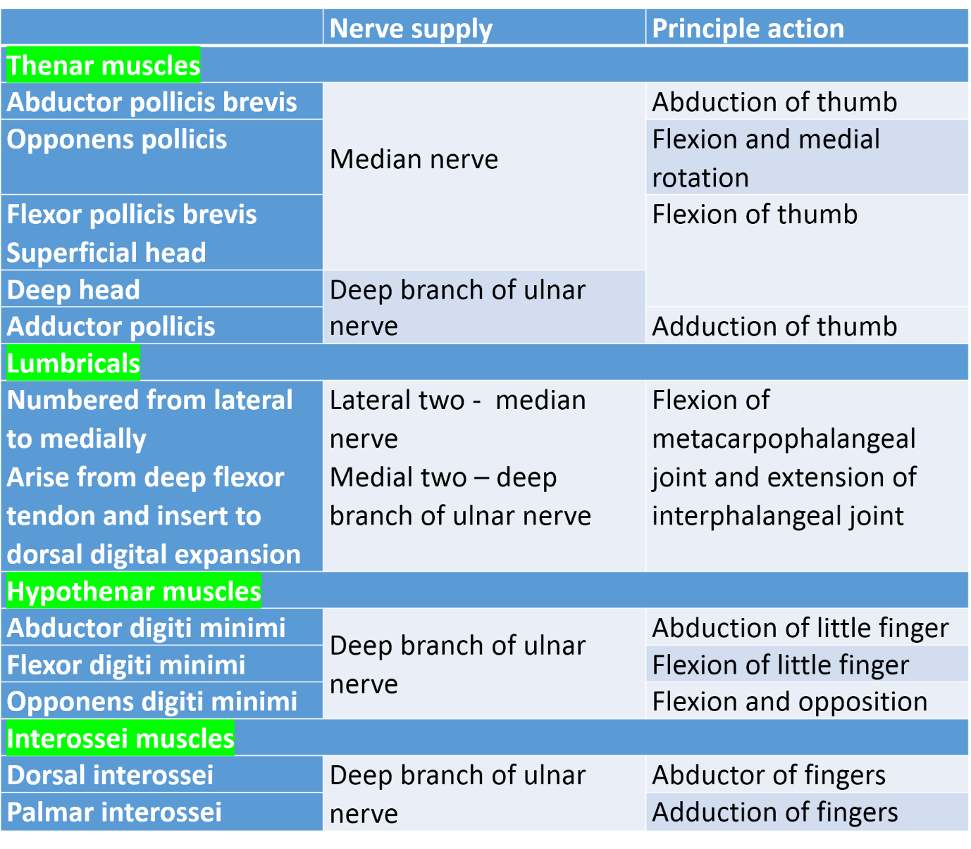
[CLINICAL] Important points
- All thenar muscles are supplied by median nerve except adductor pollicis and deep head of flexor pollicis brevis
- All hypothenar muscles are supplied by deep branch of ulnar nerve except palmaris brevis supplied by superficial branch of ulnar nerve
- All interossei are supplied by deep branch of ulnar nerve
- The same nerve supplies lumbricals and the tendon from which arises.
- There are two dorsal interossei for the middle finger
- The thumb and little finger have their own abductors and hence has no dorsal interossei
- Palmar interossei adducts (PAD) and dorsal interossei abducts (DAB)

